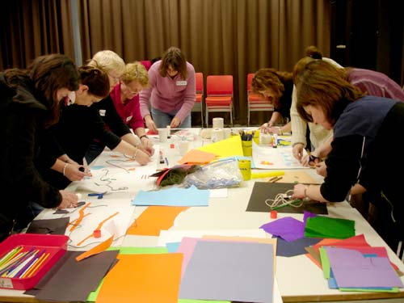

***Do you want to:***

* ***support your child’s learning?***
* ***connect with other parents?***
* ***go on Field Trips?***

***Do you want to learn about:***

* ***computers?***
* ***your community and Canada?***
* ***how the school system works?***

***…and much, much more!***

***Queen Mary Family Learning Program***

***A free program for families in the City of North Vancouver, including***

***Queen Mary, Westview and Ridgeway Elementary Schools***

***(program runs from October 2018 to June 2019 - see details below)***

***When:***

***Children and Parents/Caregivers:***

***Wednesdays (starts on Oct. 3rd)***

***3:15 - 4:45 pm***

***(Door opens at 2:15 pm)***

***Parents and Caregivers:***

***Thursdays (starts on Oct. 4th)***

***9:00 to 11:00 am***

***(Door opens at 8:30 am)***

***Where:***

***St. John the Evangelist***

***Anglican Church***

***(220 West 8th Street, North Vancouver)***

**(behind Queen Mary School)**

MC900250821[1]

**Come and have a** **snack and a cup of coffee and learn more about the program**

**Activities and supervised play are available for your younger children while you learn**

***For more information on the:***

***Wednesday sessions contact: Michelle Lebeau - Instructor - Capilano University***

***Ph.: 604-986-1911 Local: 5824 Email:*** [***Mlebeau@capilanou.ca***](mailto:Mlebeau@capilanou.ca)

***Thursday sessions contact: Claudio Lerner - Instructor - Capilano University***

***Ph.: 604-986-1911 Local: 7245 Email:*** [***clerner@capilanou.ca***](mailto:clerner@capilanou.ca)

***We gratefully acknowledge the support of the City of North Vancouver through their Community Grant program.***

*Supported by: City of North Vancouver, Raise A Reader (The Vancouver Sun), B.C. Ministry of Advanced Education,*

*St. John the Evangelist Anglican Church, Queen Mary Elementary School, Capilano University, North Shore Neighbourhood House, City of North Vancouver Library, and the North Shore Multicultural Society*